

**CHM. 313**

**Experiment 7:** Alkyl Halides

Name:

Date:

**Group #:**

**Objective:**

1. To synthesize t-butyl chloride from t-butyl alcohol via SN1 mechanism.
2. To practice using a separatory funnel extraction and distillation

**Theory:**

An **alkyl halide** is another name for a halogen-substituted alkane. The carbon atom, which is bonded to the halogen atom, has sp3 hybridized bonding orbitals and exhibits a tetrahedral shape. Due to electronegativity differences between the carbon and halogen atoms, the σ covalent bond between these atoms is polarized, with the carbon atom becoming slightly positive and the halogen atom partially negative.

* **Reaction of Alcohol with Hydrogen Halide:**

Substitution of alcohols using HX

The properties of this substitution reaction are:

* Nucleophilic Substitution:
  + Mononuclear (SN1): Tertiary Alcohols ( t-Butyl Alcohol)
  + Bimolecular (SN2): Primary and Secondary Alcohols. (n-Butyl Alcohol)
* When treated with HBr or HCl, alcohols typically undergo a nucleophilic substitution reaction to generate an alkyl halide and water.
* Reaction usually proceeds via an [SN1 mechanism](http://www.chem.ucalgary.ca/courses/351/Carey/Ch04/ch4-4-1.html) which proceeds via a [carbocation intermediate](http://www.chem.ucalgary.ca/courses/351/Carey/Ch04/carbocation.html) that can also undergo rearrangement.

|  |  |  |
| --- | --- | --- |
|  | [tert-Butanol](http://en.wikipedia.org/wiki/Image:Tert-butanol-2D-skeletal.png) | [100px-Tert-butyl-chloride-2D-skeletal](http://en.wikipedia.org/wiki/Image:Tert-butyl-chloride-2D-skeletal.png) |
| **Name** | **Tert-butyl alcohol** | **T-butyl chloride** |
| **Molecular formula** | C4H10O | C4H9Cl |
| **Molar mass** | 74.1216 g/mol | 92.57 g/mol |
| **MP** | 25.69°C | -25°C |
| **BP** | 82.4°C | 51-52°C |
| **Density** | 0.78 g/ml | 0.85 g/ml |
| **Physical state** | Solid at Room T | Colorless Liquid |

We will convert t-Butyl Alcohol (2-methyl-2-propanol) rapidly to t-Butyl Chloride (2-chloro-2-methylpropane) via use of concentrated HCl at room temperature. Since t-Butyl Alcohol is tertiary alcohol the SN1 mech is followed which has the following reactions:

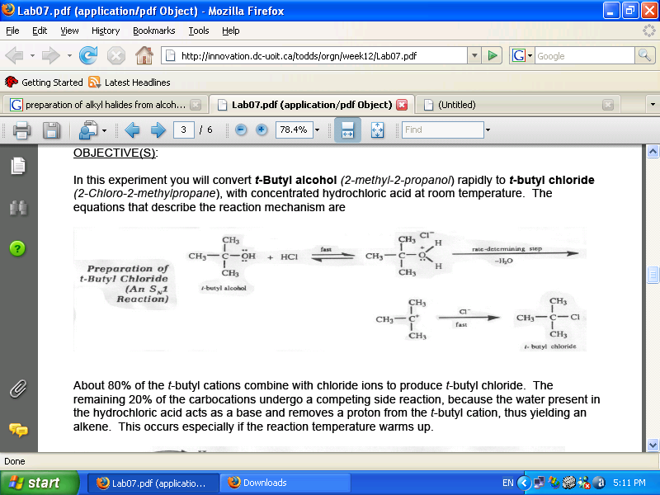

About 80% of the t-Butyl cations combine with chloride ions to produce t-butyl chloride. The remaining 20%of the carbocations undergo a competing side reaction, because the water present in the HCl acts as a base and removes a proton from the t-Butyl cation, thus yielding an alkene via an elimination reaction. This occurs especially if the reaction temperature warms up.

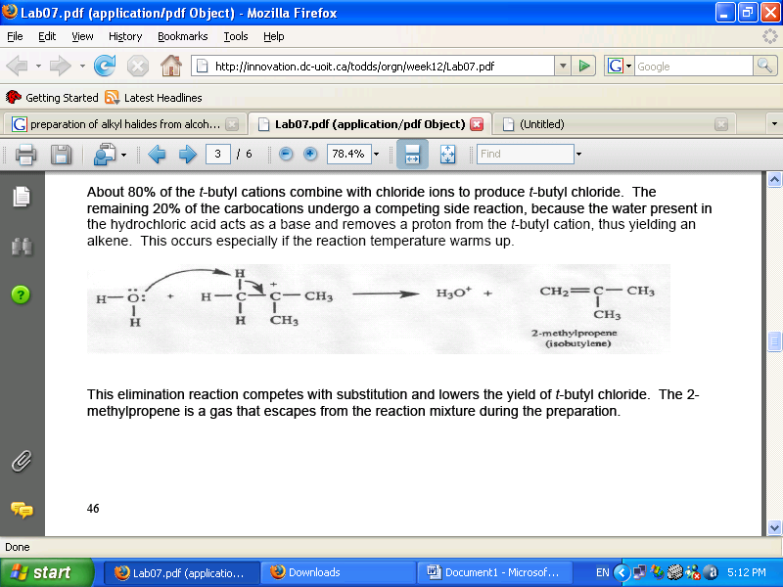The elimination reaction competes with substitution and lowers the yield of t-Butyl Chloride. The 2-methylpropene is a gas that escapes from the reaction mixture during the preparation.

**N.B:** The cooler the HCl, the less elimination that will occur.

**Procedure:**

1. **Preparation of t-Butyl Chloride SN1:**
2. Place 5g of t-Butyl Alcohol in a separatory funnel.
3. Place 25 ml of cold concentrated HCl (36% weight).
4. Shake mixture for 10-15 min releasing pressure occasionally while slowly opening the stopcock.
5. Draw off the lower layer which is the aqueous layer, and discard it.
6. Add 15 ml of cold water and then discard the aqueous layer.
7. Repeat with 15ml of Na2CO3 where CO2 is evolved during neutralization and then discard the aqueous layer.
8. Place 15ml of cold water (preferred to be saturated with NaCl) and then discard the aqueous layer.
9. Transfer the organic layer (t-Butyl Chloride) to a DRY volumetric flask and add anhydrous CaCl2 or MgSO4.
10. Perform decantation or filtration into a 50 ml round bottom flask and add boiling stones.
11. Perform distillation and collect the volumes from 49-52oC which is the volume of t-Butyl Chloride.
12. Find the percentage yield.
13. **Preparation of n-Butyl Bromide SN2:**
14. Prepare HBr solution.
15. Add 14ml of concentrated H2SO4 in 2-3 ml portions.
16. Add 2 boiling stones and reflux (heat to BP) for 30 min.
17. Cool the reaction mixture and perform distillation until reaching 110-115oC temperature obtaining only H2O solution.
18. Transfer distillate to separatory funnel and add 25 ml of water discarding the lower layer.
19. Add 25 ml of NaOH (10%) also discarding the lower layer.
20. Transfer the organic layer to a DRY volumetric flask and add anhydrous CaCl2 or MgSO4.
21. Perform decantation or filtration into a 50 ml round bottom flask and add boiling stones.
22. Perform distillation and collect the volumes from 98-102oC which is the volume of n-Butyl Chloride.
23. Find the percentage yield.

**Results:**

1. **Preparation of t-Butyl Chloride SN1:**

|  |  |  |  |  |
| --- | --- | --- | --- | --- |
| **Reactant** | **M.Weight (g/mol)** | **Volume (ml)** | **Density (g/ml)** | **Moles (mol)** |
| **t-Butyl Alcohol** | 74.12 | 6.6 | 0.78 | 0.07 |
| **Hydrochloric Acid** | 36.5 | 25 | 1.15 | 0.79 |

**The compound that limits the yield is:** t-Butyl Alcohol

**The theoretical yield of t-Butyl Chloride:**

$$m_{theoretical of t-butyl chloride}=\frac{M_{t-butylchloride}m_{t-butyl alcohol}}{M_{t-butylalcohol}}=\frac{92.57×5.15}{74.12}=6.48g$$

$$n_{theoretical of t-butyl chloride}=\frac{m_{t-butylchloride}}{M_{t-butylchloride}}=0.07 mol$$

**Experimental yield of n-Butyl Chloride:**

$$m_{ n-butyl chloride}=4.18 g$$

$$\%yeild=\frac{m_{ n-butyl chloride}}{m_{theoretical of n-butyl chloride}}×100=64.52\%$$

1. **Preparation of n-Butyl Bromide SN1:**

|  |  |  |  |  |  |
| --- | --- | --- | --- | --- | --- |
| **Reactant** | **M.Weight (g/mol)** | **Grams (g)** | **Volume (ml)** | **Density (g/ml)** | **Moles (mol)** |
| **n-Butyl Alcohol** | 74.12 | 8 | 10 | 0.8 | 0.06 |
| **Sodium Bromide** | 102.9 | 13.6 |  |  | 0.13 |
| **48% HBr** | 80.912 | 4.85 | 3.25 | 1.49 | 0.06 |
| **Sulfuric Acid** | 98.08 | 26.5 | 14.4 | 1.84 | 0.27 |

**The compound that limits the yield is:** n-Butyl Alcohol

**The theoretical yield of n-Butyl Chloride:**

$$m_{theoretical of n-butyl bromide}=\frac{M_{n-butylbromide}m_{n-butyl alcohol}}{M_{n-butylalcohol}}=\frac{137.02×8}{74.12}=14.79g$$

$$n_{theoretical of n-butylbromide}=\frac{m_{n-butylbromide}}{M_{n-butylbromide}}=0.107 mol$$

**Experimental yield of n-Butyl Chloride:**

$$m_{ n-butyl bromide}=7.87 g$$

$$\%yeild=\frac{m_{ n-butyl bromide}}{m_{theoretical of n-butyl bromide}}×100=53.24\%$$